TASK 1: HOW TO ESTABLISH PASSWORDLESS CONNECTION BETWEEN MASTER AND SLAVE

1 Install Filezilla client. Go to Edit -> Setting -> SFTP -> Add Keyfile Give the IP address of the master and port 22 , username ubuntu. Then transfer the pem file to ubuntu folder 2 Stop all firewall sudo service ufw stop 3 Start ssh sudo service ssh start 4 Add the ssh details eval `ssh-agent -s` sudo chmod 400 ssh-add

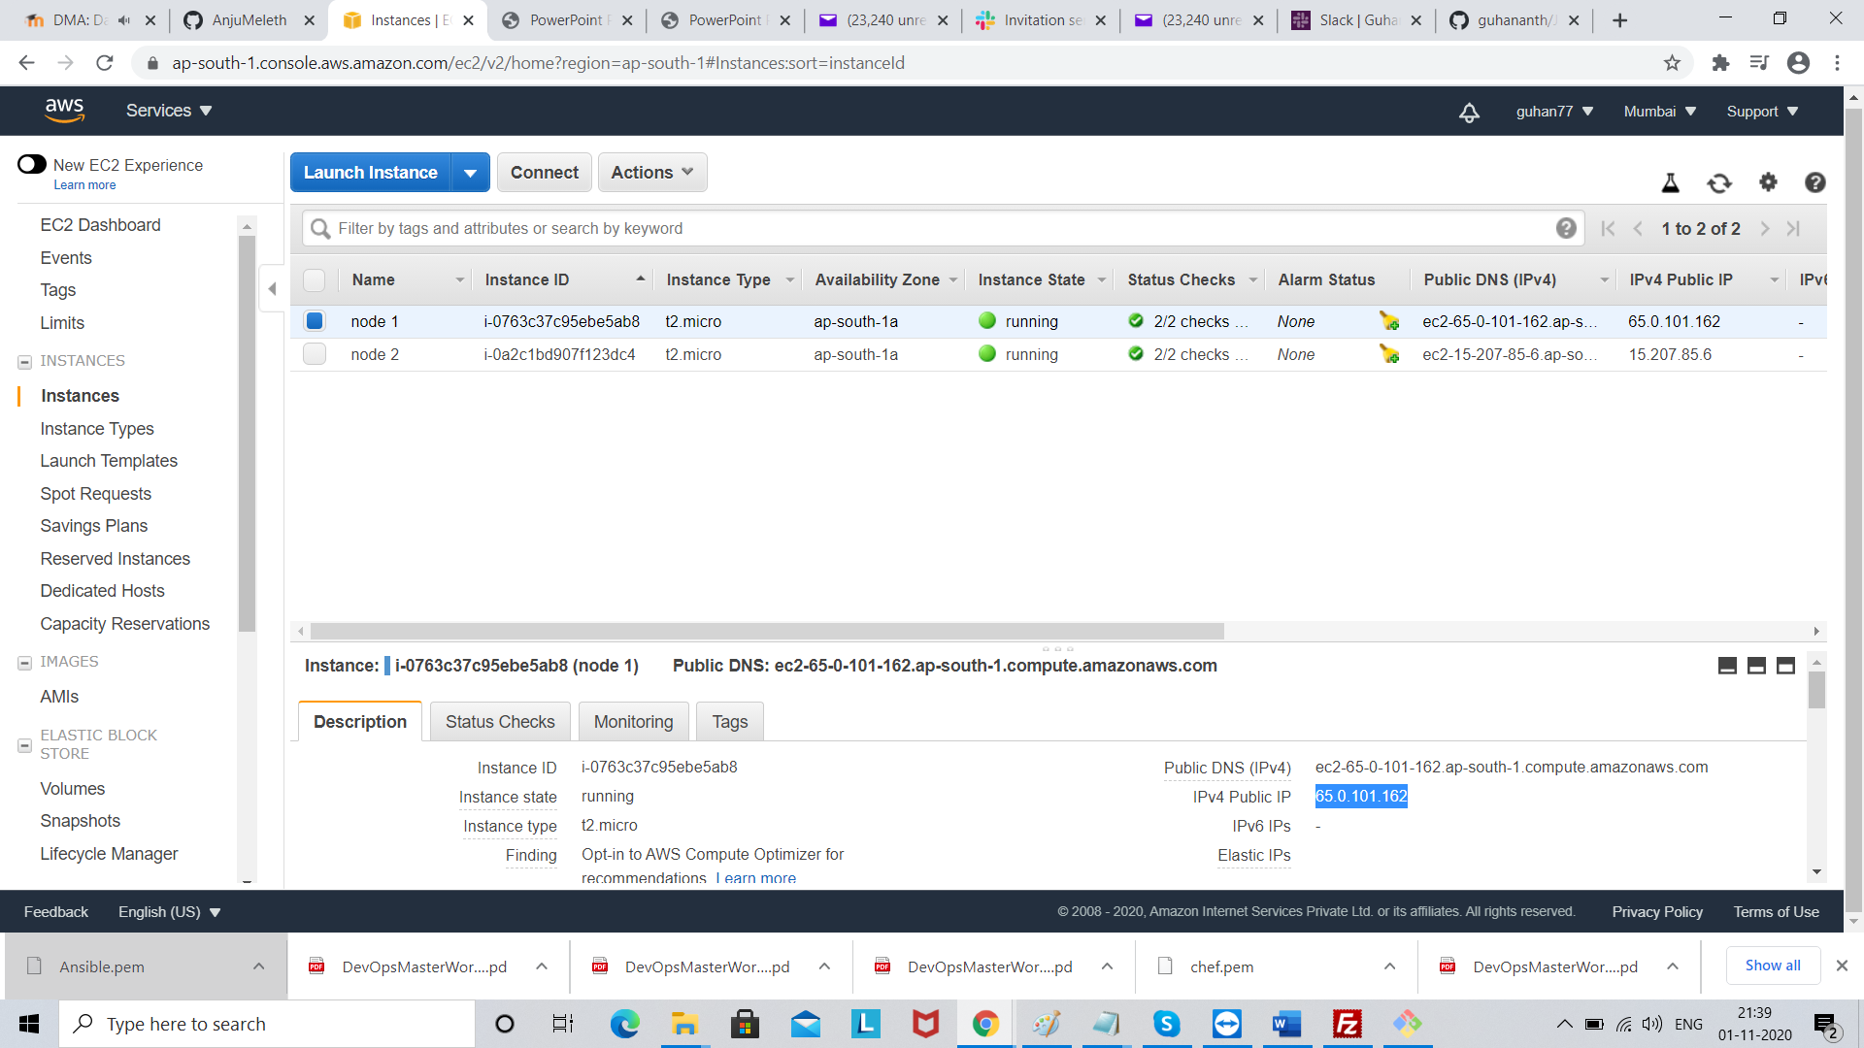

Open File zilla

Go to settings add temp file

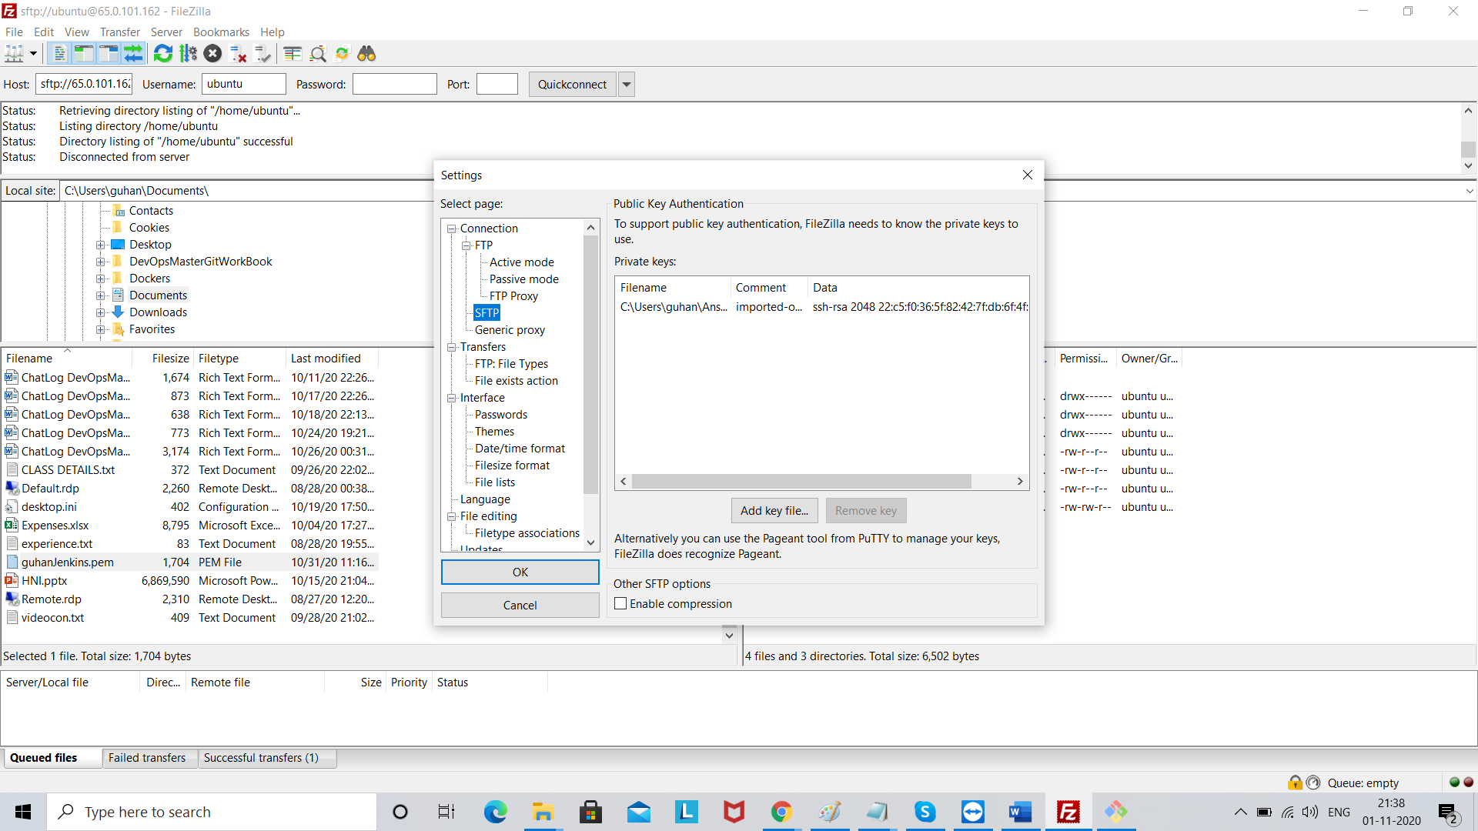

Click Quick connect

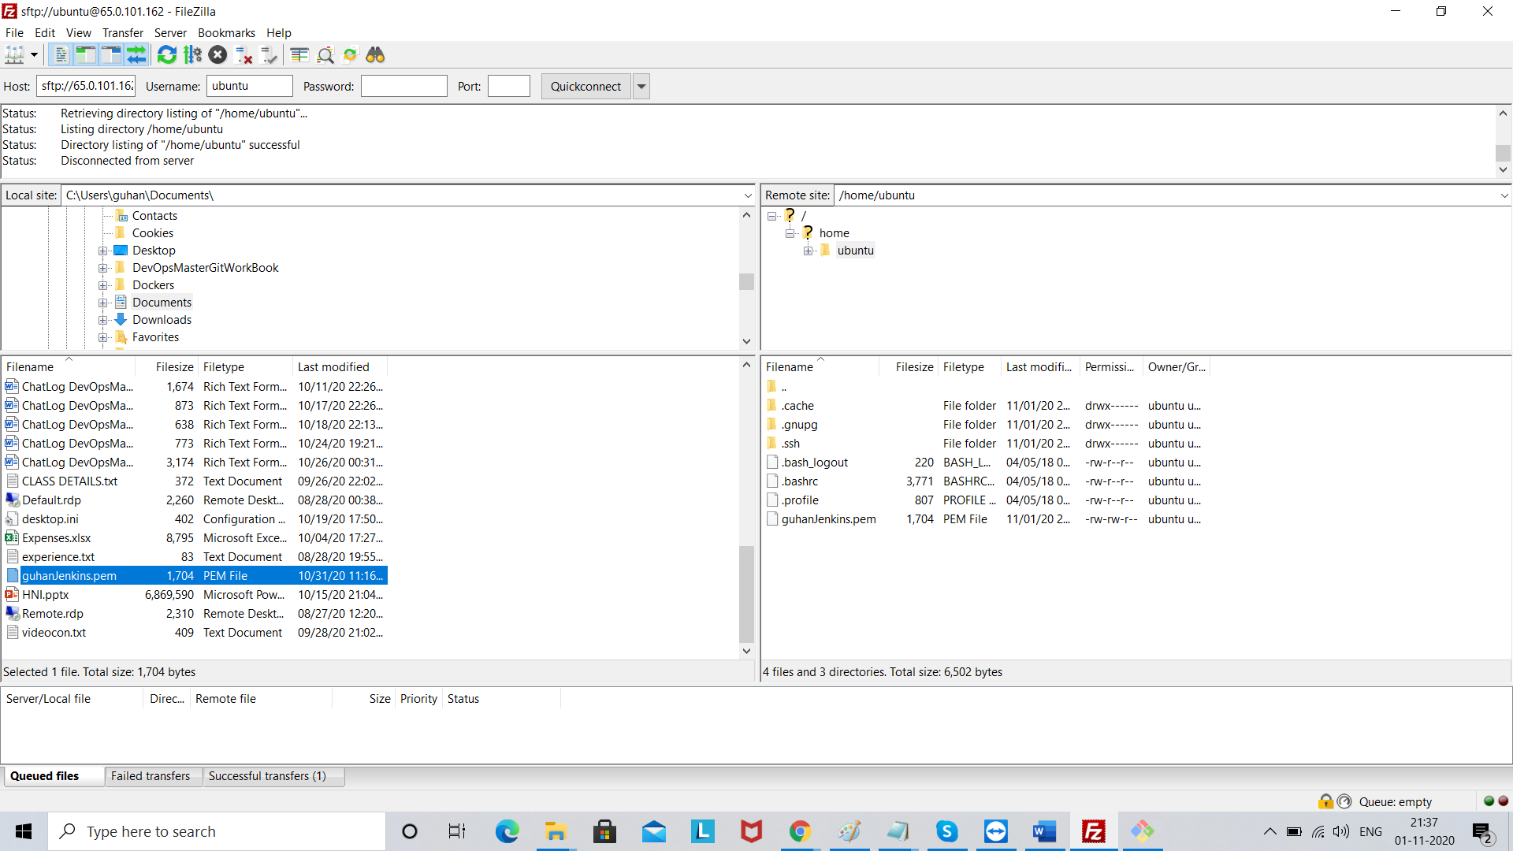

guhan@LAPTOP-V8JK9MGG MINGW64 ~ (master)

$ cd C:

guhan@LAPTOP-V8JK9MGG MINGW64 /c

$ cd Users

guhan@LAPTOP-V8JK9MGG MINGW64 /c/Users

$ cd guhan

guhan@LAPTOP-V8JK9MGG MINGW64 ~ (master)

$ cd Document

bash: cd: Document: No such file or directory

guhan@LAPTOP-V8JK9MGG MINGW64 ~ (master)

$ cd Documents

guhan@LAPTOP-V8JK9MGG MINGW64 ~/Documents (master)

$ ssh -i "guhanJenkins.pem" ubuntu@ec2-65-0-101-162.ap-south-1.compute.amazonaws.com

load pubkey "guhanJenkins.pem": invalid format

The authenticity of host 'ec2-65-0-101-162.ap-south-1.compute.amazonaws.com (65.0.101.162)' can't be established.

ECDSA key fingerprint is SHA256:lMprtyzA1v3ljqLc28MHLdWrWtcGig6YFThvIJxUq98.

Are you sure you want to continue connecting (yes/no/[fingerprint])? yes

Warning: Permanently added 'ec2-65-0-101-162.ap-south-1.compute.amazonaws.com,65.0.101.162' (ECDSA) to the list of known hosts.

Welcome to Ubuntu 18.04.5 LTS (GNU/Linux 5.3.0-1035-aws x86_64)

* Documentation: https://help.ubuntu.com

* Management: https://landscape.canonical.com

* Support: https://ubuntu.com/advantage

System information as of Sun Nov 1 15:51:57 UTC 2020

System load: 0.01 Processes: 95

Usage of /: 14.4% of 7.69GB Users logged in: 0

Memory usage: 18% IP address for eth0: 172.31.46.32

Swap usage: 0%

0 packages can be updated.

0 updates are security updates.

The programs included with the Ubuntu system are free software;

the exact distribution terms for each program are described in the

individual files in /usr/share/doc/*/copyright.

Ubuntu comes with ABSOLUTELY NO WARRANTY, to the extent permitted by

applicable law.

To run a command as administrator (user "root"), use "sudo <command>".

See "man sudo_root" for details.

ubuntu@ip-172-31-46-32:~$ ssh -i "guhanJenkins.pem" ubuntu@ec2-65-0-101-162.ap-south-1.compute.amazonaws.com

Warning: Identity file guhanJenkins.pem not accessible: No such file or directory.

The authenticity of host 'ec2-65-0-101-162.ap-south-1.compute.amazonaws.com (172.31.46.32)' can't be established.

ECDSA key fingerprint is SHA256:lMprtyzA1v3ljqLc28MHLdWrWtcGig6YFThvIJxUq98.

Are you sure you want to continue connecting (yes/no)? yes

Warning: Permanently added 'ec2-65-0-101-162.ap-south-1.compute.amazonaws.com,172.31.46.32' (ECDSA) to the list of known hosts.

ubuntu@ec2-65-0-101-162.ap-south-1.compute.amazonaws.com: Permission denied (publickey).

ubuntu@ip-172-31-46-32:~$ sudo service ufw stop

ubuntu@ip-172-31-46-32:~$ sudo service ssh start

ubuntu@ip-172-31-46-32:~$ eval 'ssh-agent-s'

ssh-agent-s: command not found

ubuntu@ip-172-31-46-32:~$ eval `ssh-agent -s`

Agent pid 1912

ubuntu@ip-172-31-46-32:~$ sudo chmod 400 guhanJenkins.pem

ubuntu@ip-172-31-46-32:~$ ssh-add guhanJenkins.pem

Identity added: guhanJenkins.pem (guhanJenkins.pem)

ubuntu@ip-172-31-46-32:~$ ssh ubbunto@15.207.85.6

ubbunto@15.207.85.6: Permission denied (publickey).